# **Six Output Programs**

**HW_2a**.

Write a C++ program that outputs to the screen: C++ programming is easy!

Copy and Paste the output below your source code.

Note: For all 5 parts, include an information section at the top of each program. (See syllabus)

* Include your name, class, and homework in comments.
* Make sure to include the separator lines as shown in the syllabus.

**HW_2b**.

* Declare a variable of *int* data type.
* Name the variable *myAge*.
* Initialize the variable with your age. (If you are 21, then assign 21, etc.)
* Write a statement that outputs your age to the screen.

(Use the variable in the output statement).

Output: My age is 21

Press any key to continue . . .

Copy and Paste the output below your source code.

Note: Include an information section at the top with your name, class, homework, and the

separator lines as shown in the syllabus.

**HW_2c**

* Declare two variables of string data type.
* Name the first variable ***firstName***, and the ***lastName***.
* Write a statement that assigns your first name to the variable ***firstName***.
* Write a statement that assigns your last name to the variable ***lastName***.
* Write a statement that says: **My first name is Dennis.** (use your name)
* Write another statement that says: **My last name is Rainey.** (use your name)
* Use the **endl** manipulator to place the second statement on the next line down.

Use variables for first and last names.

/* OUTPUT (Don’t just type your name)

My first name is **Dennis**.

My last name is **Rainey**.

Press any key to continue ... */

Refer to Lecture 2 for declaring variables.

Copy and Paste the output below your source code.

Note: For all 5 parts, include an information section at the top of each program. (See syllabus)

Create a fourth project **HW_2d**.

Create a .cpp file **HW_2d**.

* Declare two variables of string data type.
* Name the first variable ***school***, and the second variable ***city***.
* Write a statement that assigns “Norco College” to ***school*** (or whatever

school you attend). (Remember strings must be surrounded by double quotes).

* Write another statement that assigns “Orange” to the variable ***city***.

(or whatever city your school is in).

* Write code to produce the output below.
  + Make sure to use the ***school*** and ***city*** variables in your output statements. (Don’t just type Santiago Canyon College and Orange).

These are variables

/* OUTPUT

My school is **Santiago Canyon College**.

It is in the city of **Orange**.

Press any key to continue ... */

Refer to **Lecture 2** declaring variables, andfor assigning values and outputting strings.

Note: For all 5 parts, include an information section at the top of each program. (See syllabus)

* Include your name, class, and homework in comments.
* Make sure to include the separator lines as shown in the syllabus.

Create a fifth project **HW_2e**.

Create a .cpp file **HW_2e**.

* Declare two variables of char data type.
* Name the first variable **firstInitial**, the second variable **lastInitial**.
* Ask the user to enter his or her first initial.

Ex: Enter your first initial: T 🡨 The user enters a T

* + Use the cin object and extraction operator to read in the value entered by the user.
  + The input value should be held in the variable named: **firstInitial**.
* Ask the user to enter his or her first initial.

Ex: Enter your last initial: L 🡨 The user enters an L

* + Use the cin object and extraction operator to read in the value entered by the user.
  + The input value should be held in the variable named: **lastInitial**.
* Output the following statement:
  + Use variables to output T and L. (Don’t just type in the letters.)

Your first initial is **T** and your last initial is **L**.

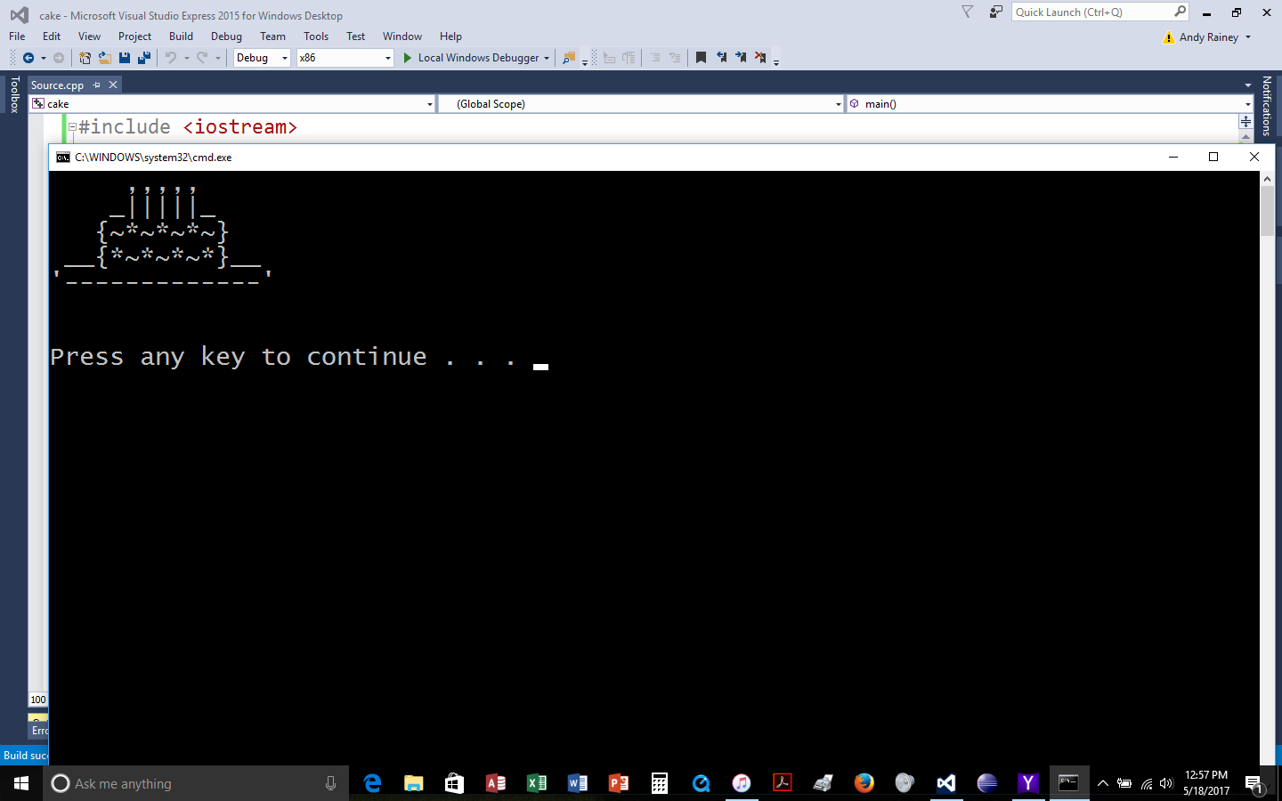

Create a fifth project **HW_2f**.

Use output statements ( cout << ) to

create a birthday cake, as shown.

(If it’s not perfect, don’t worry about it).

Copy and Paste the output below your source code.

**Classroom:** Staple all 6 parts of HW_2 (2a, 2b, 2c, 2d, 2e and 2f).

NOTE: UNSTAPLED HOMEWORK will not be accepted.

**Online class** Submit all 6 programs (HW_2 (2a, 2b, 2c, 2d, 2e and 2f) on Canvas

**IMPORTANT:**

**FOR THE ENTIRE SEMESTER** - SUBMIT YOUR HOMEWORK ON CANVAS

IN A WORD DOCUMENT, TEXT FILE OR PDF FILE..